**DAILY ONLINE ACTIVITIES SUMMARY**

|  |  |  |  |
| --- | --- | --- | --- |
| **Date:** | 7/07/2020 | **Name:** | Krishnitha |
| **Sem & Sec** | 4th sem, A Section | **USN:** | 4AL18CS039 |
| **Online Test Summary** | | | |
| **Subject** | NA | | |
| **Max. Marks** | NA | **Score** | NA |
| **Certification Course Summary** | | | |
| **Course** | Lightning Experience Customization | | |
| **Certificate Provider** | salesforce | **Duration:** | 3 hrs |
| **Coding Challenges** | | | |
| **Problem Statement:** Write a Java Program to find the Hidden Number. | | | |
| **Status:** Executed | | | |
| **Uploaded the report in GitHub** | | YES | |
| **If yes Repository name** | | <https://github.com/krishnitha/Java-coding> | |
| **Uploaded the report in slack** | | YES | |

**Certification Course Details:**

Today I continued the course “Lightning Experience Customization” by salesforce. Today I learnt about Custom object highlights, details and compact layouts. And also learnt how to create and edit custom buttons and links. Today I have successfully completed this course and have received two badges for the same.

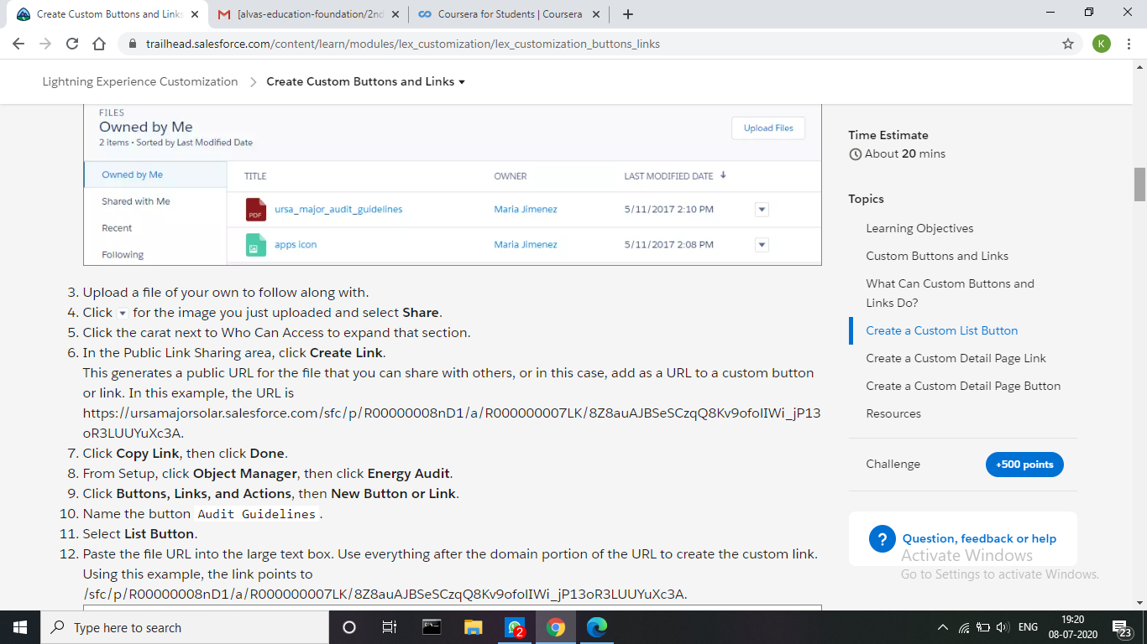

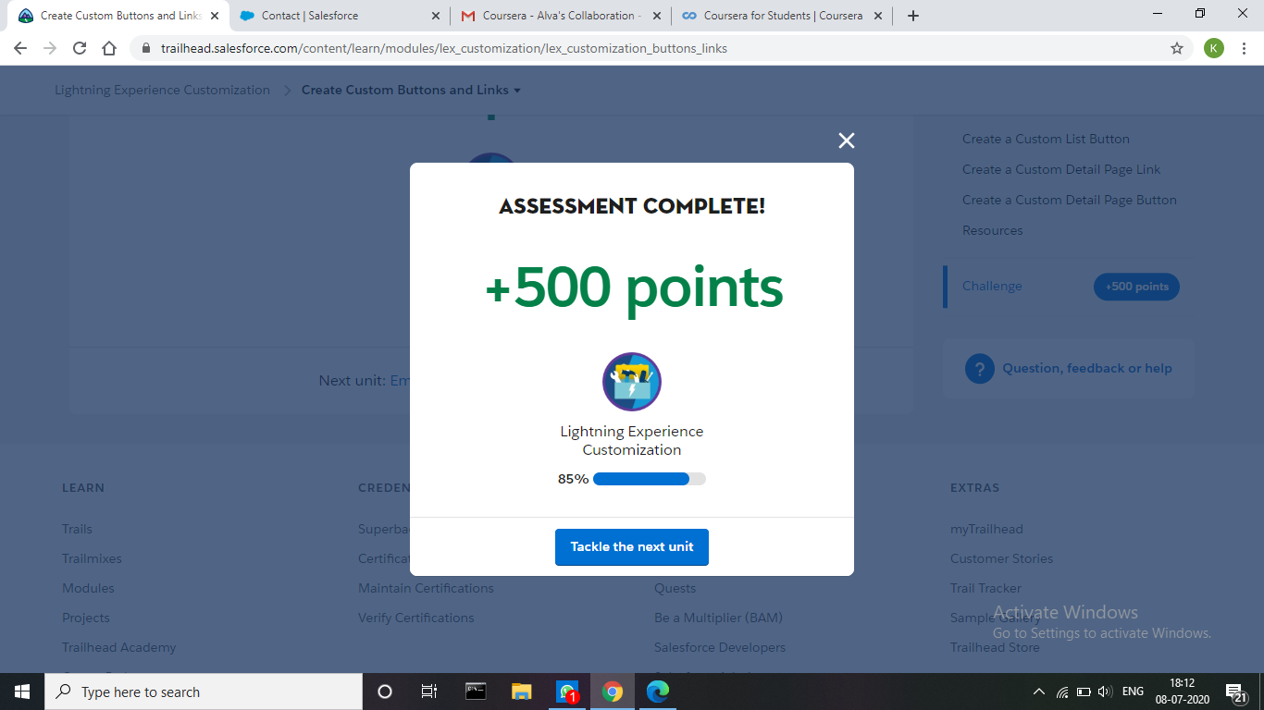



**Coding Challenges Details:**

# **Problem:** Write a Java Program to find the Hidden Number.

Given an array of integers, the task is to find another integer such that, if all the elements of the array are subtracted individually from the number, then the sum of all the differences should add to 0. If any such integer exists, print the value of, else print.

**Example:**

**Input:** arr[] = {1, 2, 3}

**Output:** 2

**Explanation:**

Substracting all the elements of arrays from 2,

The sum of difference is:

1 + 0 + (-1) = 0.

**Solution:** Uploaded it in GitHub

